**Unit 8 Geometric Measurements**

Name:_________________________

Mr. Ortega

7th Grade Math

Name:_________________________ Date:__________________

Learning Target: _______________________________________________________________

_____________________________________________________________________________

_____________________________________________________________________________

**Opener**

|  |
| --- |
| 1. An item was purchased for m dollars, which includes sales tax. Sales tax was 7%. Which expression represents the price of the item before sales tax?  A. *m* + 0.07 B. *m* – 0.07  C. *m* x 1.07 D. *m $÷$* 1.07 |

|  |
| --- |
| 2. Which is equivalent to the expression –7.5x + 12.5?   A. 5x B. -2.5(3x – 5)  C. -2.5(3x + 5) D. 2.5(-3x + 12.5) |

Circumference and Area of a Circle

|  |  |
| --- | --- |
| Formula for Circumference of a Circle, and when to use it: | Formula for Area of a Circle, and when to use it: |

r = d =

Find the circumference and area of each circle below:



1. 2. 3. 4.

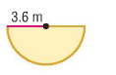

5. Find the area of the semi-circle shown:

6. A 360° rotating sprinkler that sprays water at a radius of 11 feet is used to water a lawn. What is the area of the lawn that is watered by this sprinkler?

7. The diameter of a bike wheel is 2 ft. How far will the bike go in one rotation of the wheel?

8. Brixx makes 10’’ pizzas (that is the diameter). What is the area of a Brixx pizza?

Area and Circumference of Circles

**Find the area of each semicircle. Round to the nearest tenth.**

9 in.

3 in.

**1.**

**13.** **SPOTLIGHT** A spotlight can be adjusted to effectively light a circular area of up to 6 meters in diameter. To the nearest tenth, what is the maximum area that can be effectively lit by the spotlight?

14 cm

6.1 m

13 km

12 ft

7.1 m

3.8 yd

**14.** **ARCHERY** The bull’s eye on an archery target has a radius of 3 inches. The entire target has a radius of 9 inches. To the nearest tenth, find the area of the target outside of the bull’s eye.

**8.** radius = 3 $\frac{1}{2}$ ft

5.6 cm

42 yd

**12.**

**11.**

**10.**

**9.** radius = 8 in.

**7.** diameter = 9.4 mm

4 in.

**6.**

**5.**

**4.**

**3.**

**2.**

**Find the area and circumference of each circle, use 3.14 for π. Round to the nearest tenth.**

Name:_________________________ Date:__________________

Learning Target: _______________________________________________________________

_____________________________________________________________________________

___________________________________________________________________

Opener

1. How much interest will you earn on an investment of $1500 at a rate of 6.5% over a period of 6 years?

2. 600 people were surveyed regarding their favorite flavor of skittle. 350 chose strawberry. What percent of the people chose strawberry?

3. In January we received 5.4 inches of precipitation. In February, we received 6.2 inches of precipitation. What is the percent increase from January to February?

Composite Figures Class Assignment

Calculate the area of each figure below.

1.  2.



3. 4.

 Calculate the area of the shaded region.

5.  6.



7. 8.

Area of Composite Figures (shapes stuck together!)

Brain Dump: Complete as many as you can

|  |  |  |  |  |
| --- | --- | --- | --- | --- |
| **Perimeter** | **Circumference** | **Area of a**  **Rectangle** | **Area of a Circle** | **Area of a**  **Triangle** |
|  |  |  |  |  |

A composite figure is made up of ____________ _________ ______________ shapes. To find the area, decompose the figure into shapes with areas you know, then ____________.

Examples:

1.  2. 3. 

When the shapes are inside each other, you are asked to find the area of a “shaded region.” To do this, find the area of each figure, then __________________.

Examples:

4. 5. 6. 

Name:_________________________ Date:__________________

Learning Target: _______________________________________________________________

_____________________________________________________________________________

_____________________________________________________________________________

**Working Backwards with Formulas Opener**

1. A sprinkler sprays water by rotating in a full circle. At low pressure, the water sprays at a radius of 10 ft. At high pressure, the water extends to a radius of 14 ft. How many more square feet are watered when the sprinkler is set at high pressure?

2. The floor layout of a closet is shown below. If you want to replace the carpeting in the closet, and it costs $12.99 per square foot, plus 6% sales tax, how much will it cost to replace the carpet?

13ft 6 ft

6 ft

**Discuss the question below with your table group. Raise your hand when your group can show us an EQUATION that could help solve the problem.**

Example 1: The area of a rectangle is 24 square centimeters. If the length is 8 cm, what is the width?

What is the formula for area of a rectangle?

What information do we know?

Example 2: The area of a trapezoid is 50 square feet. If the bases measure 15 feet and 10 feet, what is the height?

What is the formula for area of a trapezoid?

What information do we know?

Example 3: The circumference of a circle is 43.96 square inches. What is the length of the radius?

What is the formula for circumference of a circle?

What information do we know?

Example 4: The area of a triangle is 60 square centimeters. If the height is 12 cm, what is the length of the base?

What is the formula for area of a triangle?

What information do we know?

Example 5: The area of a parallelogram is 144 square inches. If the base measures 16 inches, what is the height?

What is the formula for area of a parallelogram?

What information do we know?

Example 6: The area of a circle is 50.24 square inches. What is the length of the radius?

What is the formula for area of a circle?

What information do we know?

Example 7: The area of a trapezoid is 80 square feet. If the bases measure 12 feet and 4 feet, what is the height of the trapezoid?

What is the formula for area of a trapezoid?

What information do we know?

Table Challenge!

|  |  |
| --- | --- |
| 1. | 2. |
| 3. | 4. |
| 5. | 6. |
| 7. | 8. |

Name:_________________________ Date:__________________

Learning Target: _______________________________________________________________

_____________________________________________________________________________

**____________________________________________________________________________________**

**Opener**

1. Calculate the area of the shaded region.

8 in

16 in

2. The area of the teacher workroom is currently 400 square feet. During the upcoming construction, the area will be increased by 20%. What will the new square footage of the teacher workroom be?

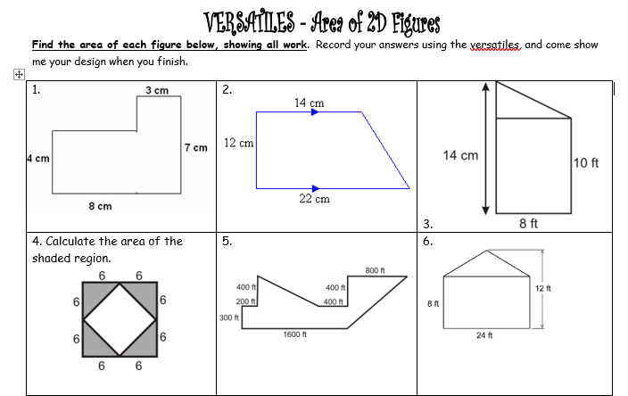

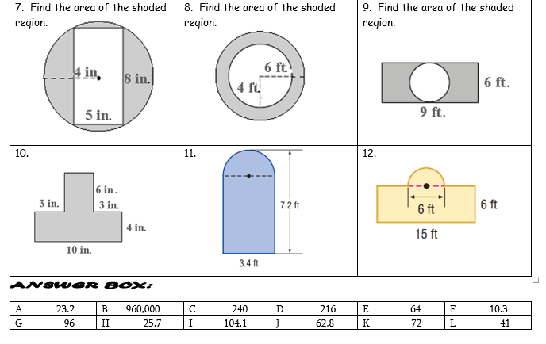

|  |  |  |
| --- | --- | --- |
| Putting It All Together   |  | | --- | | **http://www.castlelearning.com/review/Courses/geometry/q2761.gif?v=20031119010428Work the problems with your table group. If you need a hint, check the posters around the room. Check your final answers on the posters as well.**  1.  Keesha wants to tile the floor shown in the accompanying diagram. If each  tile measures 1 foot by 1 foot and costs $2.99, what will be the total cost, including  an 8% sales tax, for tiling the floor? Round your answer to the nearest cent. |  |  | | --- | | http://www.castlelearning.com/review/Courses/geometry/q3032.gif?v=20040708012128  2.  As shown in the accompanying diagram, radio station KMA is increasing its  radio listening radius from 40 miles to 50 miles. How many additional square miles  of listening area, to the *nearest tenth*, will the radio station gain? |   3.  The accompanying diagram represents a scale drawing of the property where  Brendan’s business is located. He needs to purchase rock salt to melt the ice on  the parking lot (shaded area) around his building. A bag of rock salt covers an area  of 1,500 square feet. How many bags of rock salt does Brendan need to purchase  to salt the entire parking lot? |

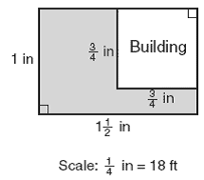

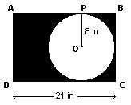4.  In the diagram, circle *O* is inscribed in rectangle *ABCD*. Radius http://www.castlelearning.com/review/Courses/integratedalgebra/segop.gif?v=20020726121854 is drawn

to http://www.castlelearning.com/review/Courses/integratedalgebra/segab.gif?v=20010728112250, *CD* = 21 inches, and *OP* = 8 inches. Find the area of the shaded region to

the NEAREST integer.